Q1. Design the device from the given I-V characteristics assuming you have two 1V sources and three 3 kΩ resistors.

I(mA)

V (V)

(-5, -3)

(3,5)

**Sol:** As the graph doesn’t go through origin, we can assume the device is a

Voltage Source in series with a Resistor.

V= IR+V0

The straight-line equation of the given I-V curve-

$$\frac{I-5}{V-3}=\frac{5-\left(-3\right)}{3-\left(-5\right)}=1 \\ or, I=V+2-----(2)$$

From equation (1) and (2), $\frac{1}{R}=1 R=1k$ and $-\frac{V_{o}}{R}= 2 V_{o}=-2V$

So, the device is:

Q2. Find out the valid range of Vin, Vo and the value of open loop gain from the following VTC-

Soln:

gain =A= slope of linear region

Slope $=\frac{15-(-15)}{5-(-5)}= \frac{30}{10}$

∴A= 3

The valid region of an amplifier is the linear region not the saturation regions. So, valid input range is:

$${-5≤V}_{in}≤5$$

Valid output range is:

$${-15≤V}_{o}≤15$$

**Q3. For ckt 1, Assume, light is on🡪 LDR resistance= 1kΩ🡪 Op-amp output, Vo= A**

**light is off🡪 LDR resistance= 50 kΩ🡪 Op-amp output, Vo= B**

**VS+= 10V, VS-= -5V, Find the value of F, I1 and I2**

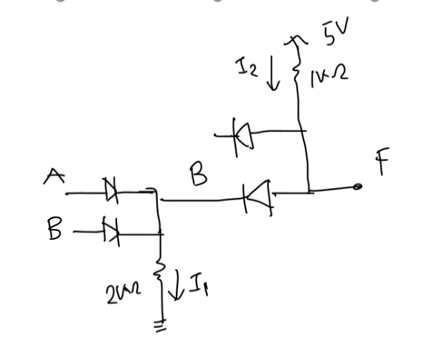

B

F1

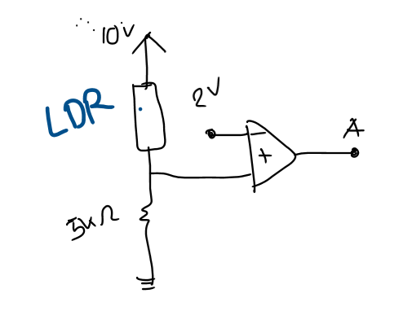

Vo

Ckt 2

Ckt 1

**Sol:**

When light is on, $V_{+}= \frac{5k}{5k +1k}10V=8.33V$

V-= 2V, So V+> V- ∴Vo= **A= VS+= 10V**

When light is off, $V_{+}= \frac{5k}{5k +50k}10V=0.909V$

V-= 2V, So V+< V- ∴Vo= **B= VS-= -5V**

**Light Off**

**Light On**



B

F1

Current, $I_{1}= \frac{F1}{2k}=\frac{10V}{2k}=5 mA$

Current, $I_{2}= \frac{5V-F}{1k}=\frac{5V-(-5V)}{1k}=10 mA$

Now,

F1= A **or** B

= max (A, B)

= max (10V, -5V) = 10V

F= B **and** F1

= min (B, F1)

= min (-5V, 10V)

**∴F = -5V**

**Q4. Draw VTC of the following circuit.**

Sol: This is an inverting op-amp.

$$Vo=-\frac{R2}{R1}Vi$$

So. gain = $-\frac{R2}{R1}=-\frac{4k}{2k}= -2$ = slope of linear region in VTC

Valid output range: $${V_{S-}≤V}_{o}≤V_{S+} or, {-3≤V}_{o}≤4$$

Now, $$Vo=gain*Vi=-2*Vi$$

when, Vo= 4V, $Vi=\frac{Vo}{-2}=\frac{4V}{-2}= -2V$

when, Vo= -3V, $Vi=\frac{Vo}{-2}=\frac{-3V}{-2}= 1.5V$

**Q5. Implement $f= \left(A+\overline{B}\right)C+\overline{D}$ with diode logic gates.**

**Sol:** There are **not gates $\overline{(B}, \overline{D})$** in this expression. But inverter (not gate) cannot be implemented by diodes. So, the given function cannot be implemented by diode logic gates.

Q6. Find Vo from the given op-amp circuit.

**Sol:**

In ideal op-amp i+= i-= 0 mA

As i+= 0 mA, so V+= 0V **[no voltage drops across 5 kΩ due to 0 current]**

So, V-= V+= 0V [virtual short circuit]

2kΩ is shorted (both node voltage= 0V)

So, this is basically an inverting op-amp

$$Vo=-\frac{R2}{R1}Vi=-\frac{3 k}{1 k}*2V= -6V$$

**2 kΩ and 5 kΩ are just dummy resistors here. They have no effect on the output of the circuit.**

Q7. Find Vo from the given op-amp circuit.

**Sol:**

**In this case, 5 kΩ is not connected to ground anymore.**

In ideal op-amp i+= i-= 0 mA

As i+= 0 mA, so V+= V2= 1V **[no voltage drops across 5 kΩ due to 0 current]**

So, V-= V+= 1V [virtual short circuit]

**Here, 2kΩ is not shorted like Q6**

Nodal equation (node V-):

**Q8:** Design separate circuits, using only diodes, to implement the following functions,

a) **z = min (vI , 7)** and **vO = max(z, 2)**

b) Draw the VTC curve. [Hint: vO vs vI]

**Sol: a)** z= 7vI [ as minimum operation means AND gate]

vO = 2+z [ as maximum operation means OR gate]

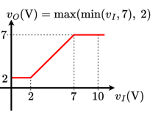b) vO = 2+z = 2 + 7vI

If vI≤2V, vO = 2 + 7vI= max (2V, min (7, vI))

= max (2V, vI) = 2V (constant)

If 2V<vI<7V, vO = max (2V, min (7, vI)) = max (2V, vI) = vI (straight line)

If vI≥7V, vO = max (2V, min (7, vI)) = max (2V, 7V) = 7V (constant)

**Q9. Find vO if vI= 0.5 V.**

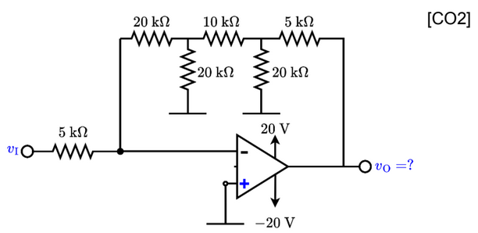

V+= 0V, So, V-= V+= 0V [virtual short circuit]

Current, $I= \frac{v_{I}-V_{-}}{5 k}=\frac{0.5 V}{5 k}=0.1 mA$

Current, $I= \frac{{(V}_{-})-V1}{20 k}=\frac{-V1 }{20 k}=0.1 mA=>V1= -2 V$

$i1= \frac{V1}{20 k}=\frac{-2 V }{20 k}=-0.1 mA$

$i2=I-i1=0.2 mA=\frac{V1-V2}{10 k}=\frac{-2 V-V2}{20 k}=>V2= -4 V$

$i3= \frac{V2}{20 k}=\frac{-4 V }{20 k}=-0.2 mA$

$i4=i2-i3=0.4 mA=\frac{V2-vo}{5 k}=\frac{-4 V-vo}{5 k}=>vo= -6 V$

**Q10. Determine v0, when vs1 = 1V and vs2 = 2V are given as inputs.**

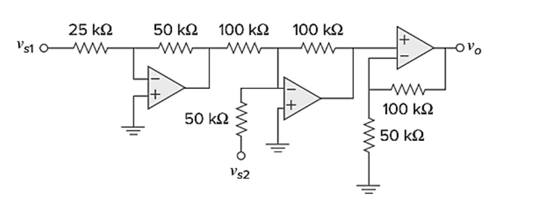

**Q11. Find diode states for the circuit shown below. Assume ideal diodes.**

Assuming D1 off (open ckt), D2 on (short ckt)

I1= 5 mA (>0) assumption ok for D2

KVL: 10 V- 3k * 5 mA + V1=0

* V1= 15 V - 10 V= 5 V

Va= V1= 15 V (as open ckt) & Vc= 0 V

Voltage difference across D1, VD= Va- Vc= 15 V (>0 V) assumption wrong for D2

So, **assumption wrong!**

Now, Assuming D1, D2 both on (short ckt)

KVL: 10 V- 3k * I1 + 2k * I2=0 –-(1)

KCL: I1 + I2 = 5 mA--- (2)

Solving (1) & (2), I1= 4 mA and I2= 1 mA

As both diode current is positive that means both D1 & D2 are ON.

**Assumption Correct!**

**Q12. Find out Vo for the following circuit.**

**Soln**:

**Q13: Draw the waveform (voltage vs time graph) of f, where y = 2 V, z = 3 V, and x has a waveform as shown in the figure on the right.**

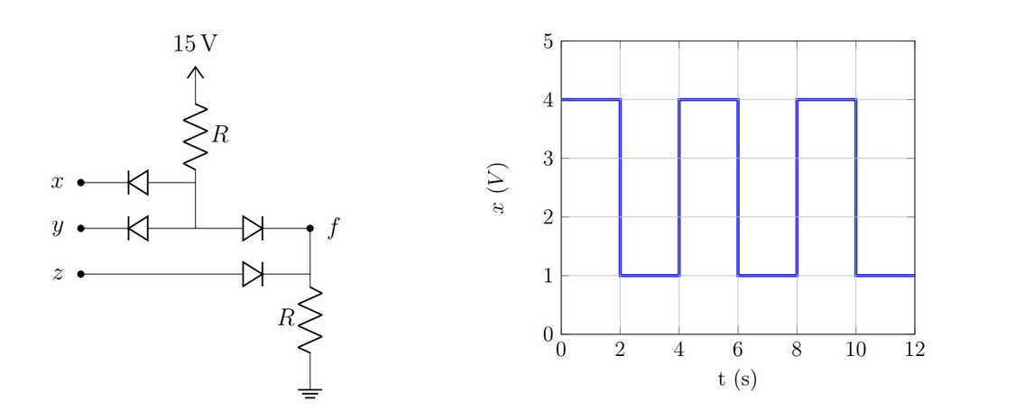

**Soln:**

**Q14: Draw the VTC of the following circuit-**

**Soln:**

**Q15: Find Vo and the states of the diodes if Vi= 10 V [consider ideal diodes].**

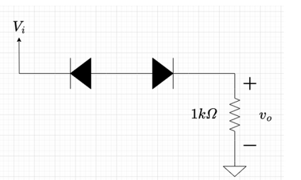

**If two diodes are connected back-to-back (both cathodes are short (a) or both anodes are short (b)), then both of the diodes must be off.**